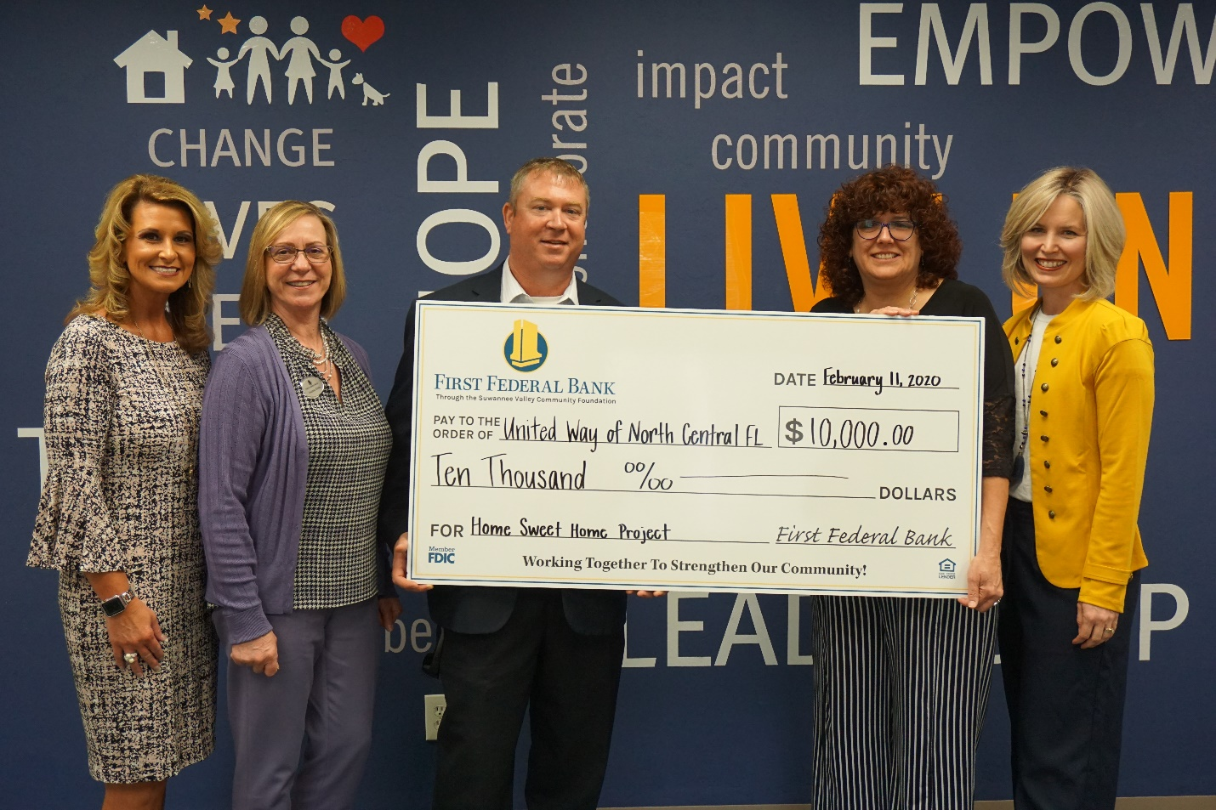

(left to right) First Federal Bank representatives Stephanie McClendon, Joanne Edde and Jason Cason presenting a check to UWNCFL President & CEO, Mona Gil de Gibaja and Family Promise Executive Director, Jayne Moraski for the Home Sweet Home initiative.

